**OS/AAPT Ohio Section Meeting: Fall 2016**

**At University of Mount Union**

Bracy Hall 1972 Clark Ave. Alliance, OH 44601

**Register at** [**http://www.osaapt.org/**](http://www.osaapt.org/)

**New Members Welcome!**

**First time visitors and high school students are always free.**

**Saturday, October 1st from 8:00 am to 3:00 pm**

8:00-8:45 **Registration** with Charles Reno --Bracy Lower Level **Light Breakfast** *(buffet, help yourself)* Bracy Lower Level

8:45-9:00 **Welcome** **& OS/AAPT $1000 Equipment Grant** available to active members Bracy 04

9:00-11:00 **Morning Workshops**

Choose A or B

|  |  |
| --- | --- |
| (9:00-10:00  **Castle Workshop**: A  Fan-tastic Alternative to Bulbs  Bob Ekey, Brandon Mitchell,  Roy McCullough, Bill Reitz  Bracy 141 | **Perimeter Institute PRTA workshop: Process of science** & other resources from PI. Everyday Einstein: GPS and relativity.  Gene Easter  Bracy 142 |
| **Castle Workshop** repeat  Bracy 141 | **What’s new at PASCO**! Smart car, Essential Physics eBook by Tom Hsu. Presenters: Julie Thomas & Brett Sackett  Bracy 142 |

11:00-12:00 **OS/AAPT Business Meeting** (Elections, etc.)

**How I do it Activities** Bracy 04

12:00-1:00 **Lunch Buffet** Bracy Lower Level

1:00-2:00 **Keynote speaker:** Kathy Malone OSU **Enhancing Your Students’ Understanding of Physics** Bracy 04

2:00-3:00 **30 demos in 60 minutes** Gene Easter, Bill Reitz, Dick Heckathorn & Mary Kay Patton

Bracy 02

3:00-3:10 **Door prizes: $100 Gift** from Vernier, **$25** gift from Arbor, plus a gift from Pasco. Bracy 02

MAP

http://www.mountunion.edu/Content/u/mtunion2D-2014-EDIT-v2-for-web-1306.pdf

Bracy is building 37. The adjacent parking lots are the best places to park.

[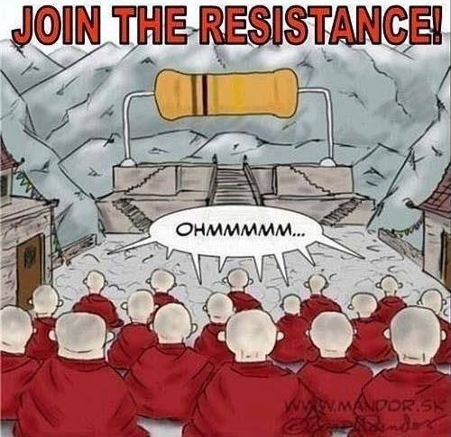](http://hawaii.aaptsections.org/)

Cartoon from the Hawaii Section AAPT

**Join the Resistance!** Share an idea—demo, lab, project, teaching strategy with your colleagues at “**How I Do it**” You could go away with **bragging rights** that your idea chosen was the best at the Section meeting. Not only that, but if the presentation that is voted by the members as best, you will receive a **FREE CRUISE** brochure, a **FREE** **NEW CAR** air freshener and **$25.** In any case, you will have helped your colleagues get new ideas, give them some enthusiasm and have some fun.

**Castle A Fan-tastic Alternative to Bulbs**

This workshop provides a hands-on experience of learning simple circuits with computer fans along with comparisons to traditional tungsten filament bulbs.  The magnitude of current through a fan is related to the frequency of the rotating fan blades, which can be seen, heard, and felt, where as the traditional bulb utilizes only vision.  Participants will explore circuits qualitatively with a set of fans and bulbs along with a battery pack or power supply.  Brief discussion of quantitative results will be presented, along with discussion of potential implementation and next steps.

**Perimeter Institute PRTA workshop process of science**, & other resources from PI: The mystery of Dark matter, Beyond the Atom: remodeling particle physics, revolutions in science, Everyday Einstein: GPS and relativity, The challenge of Quantum reality, Alice and Bob in Wonderland

**30 demos in 60 minutes** by our panel of Physics teachers will present at least 30 dynamic demonstrations that will engage students in the wonder of physics.

**Kathy Malone**

Associate Professor, Science, Technology and Mathematics Education, Department of Teaching and Learning Faculty

Kathy Malone joined the Teaching and Learning Department at The Ohio State University in 2014 after having worked as a Albert Einstein Distinguished Educator Fellow at The National Science Foundation, a postdoctoral research fellow at the University of Pittsburgh’s Learning Research and Development Center under the guidance of Dr. Christian Schunn, and a secondary science teacher in Louisiana, Ohio and Pennsylvania.

Her PhD at Carnegie Mellon University under the guidance of Dr. Ruth Chabay is an interdisciplinary degree focusing on the learning sciences.  This suites her diverse science teaching background as she has taught physics, biology and chemistry in urban, rural and suburban contexts as well as in both private and public secondary schools.

Her research interests focus on STEM reasoning and learning in biology and physics via modeling-based activities.  In addition, she is interested in the benefits of including engineering design components in K12 science classrooms.  Kathy has been involved with Modeling InstructionTM pedagogy in science since 1995 as both a high school practitioner and an educational researcher. In addition, she is an active workshop leader of this pedagogy nation wide specifically in physics and biology.  She has been instrumental in the introduction of this pedagogy at the freshman high level in physics, in secondary biology and as a vertical integration theme in educational settings.

Areas of Expertise

* Learning and teaching of physics and biology (K-16)
* Mental Models, model-based reasoning and modeling instructio
* Verbal Protocol analysis of cognitive interviews in science
* Cognitive and metacognitive skills utilized during problems

Education

* PhD., Instruction and Cognition (with masters level in Physics), Carnegie Mellon University, 2006
* M.A. Instructional Science, Carnegie Mellon University
* M.A. Science Teaching, The University of New Orleans

**Ohio Section AAPT $1000 Equipment Grant**

Active members of the Ohio Section interested in acquiring equipment to

improve the laboratory or other hands-on experience of students in their Physics or Physical Science classes are encouraged to apply for the Ohio Section Equipment grant. Funds from this grant may be used to purchase any equipment that can be used to directly enhance the student’s learning of Physics. The total yearly amount of this grant is $1000. The Ohio Section Executive Board may decide to make this award to one applicant or to divide the money amongst several worthy applicants. Grant funds will be administered through the Ohio Section.

This grant is not intended to fund supplies or travel. Recipients of awards

will have the expectation of reporting back to the Ohio Section, at Section

meetings, on the use of the grant funds in their classrooms. This could be through a How I Do It contribution or workshop. Deadlines for application, as well as notice of grant recipients, will be announced in a timely manner by the Board