Save the date!
March 4, 2017 Spring Meeting OS/AAPT at CCC Metro Cleveland
Program:
Keynote Speaker: Eugenia Etkina
Dave Maloney (author of Tipers & Ranking Task) is presenting a 2-hour workshop
Make, Play and Learn session
How I Do It
Physics Photo contest show and awards
Award of OS/AAPT $1000 Equipment Grant
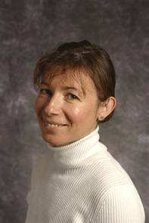

2014 Millikan Medal Awarded to Dr. Eugenia Etkina
Eugenia Etkina is a physics educator (a former high school physics teacher) who directs the physics teacher preparation program and works in the field of Physics Education Research (PER). The physics teacher preparation program prepares is one of the largest in the US and is unique in a way it trains teachers. Eugenia's research focuses on physics, student reasoning, epistemology, language, and representations. In her teaching Eugenia believes that every student can learn physics and she models interactive inquiry-based physics instruction in multiple physics teaching methods courses that are a part of the program. She advises doctoral students both in the GSE and in the Department of Physics and Astronomy. https://www.physport.org/methods

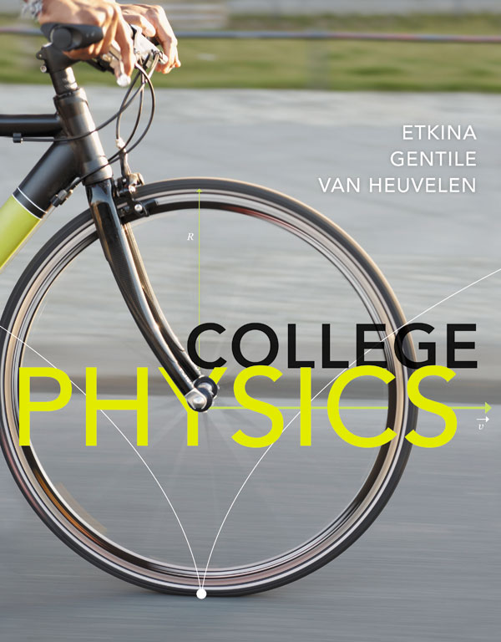
- http://pum.rutgers.edu
http://www.islephysics.net
http://paer.rutgers.edu/scientificabilities
http://paer.rutgers.edu/pt3
- http://gse.rutgers.edu/content/2014-millikan-medal-awarded-dr-eugenia-etkina
- https://sites.google.com/site/scientificabilities/
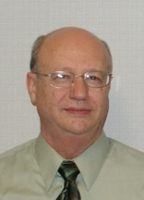
David P. Maloney, Indiana University - Purdue University Fort Wayne (Fort Wayne, Indiana)
TIPERs (Tasks Inspired by Physics Education Research) http://tycphysics.org/tipers.htm

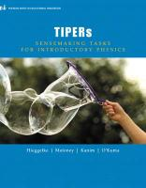

https://www.physport.org/methods/

