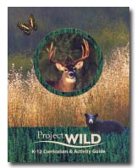
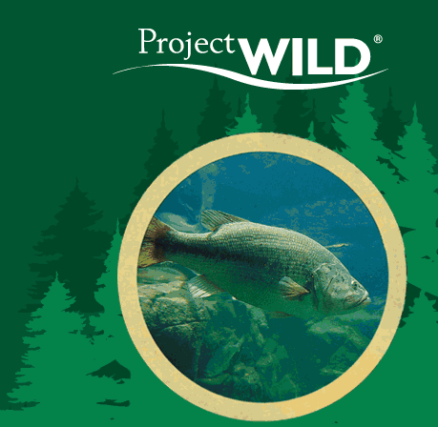
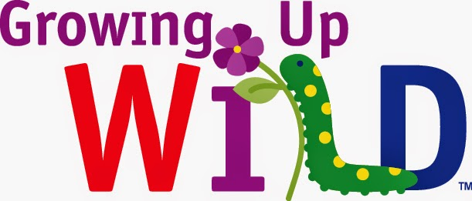
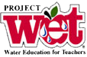

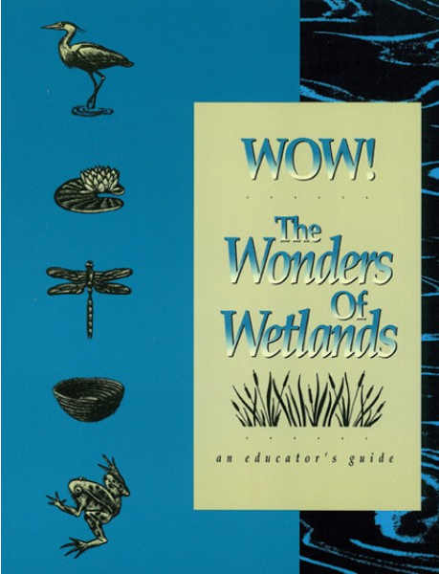
W.O.W., Wet And Wild
August 6, 7, 8, 2018

Project Wild/Aquatic Wild/Growing Up Wild, Project Wet & Wonders Of Wetlands Workshop

Three Days in the Wet and Wild: Project Wild, Growing up Wild, Project Wet, Project Wild Aquatic (K-12) and Wonders of Wetlands, are tested innovative curriculum, teaching ecology, wildlife and water resource principles that are correlated to the Ohio Academic Standards. Participants of this workshop will engage in co-operative,
hands-on activities and simulations. Upon completing the training, participants will receive the comprehensive Project Wild, Growing Up Wild, *Project Wet, Project Aquatic Wild, and Wonders of Wetlands Curriculum and Activity Guides as well as other resource material, and leave prepared and inspired to teach about ecology, wildlife, and water in the classroom or informal educational setting.

The centerpieces of this three-day workshop are the five Curriculum and Activities Guides. Written for learners of all ages, the activities are easy to use and fun! The lessons incorporate a variety of formats, such as large and small group learning,
whole-body activities, laboratory investigations, discussion of local and global topics, and community service projects.

An example of the topics in Project Wet include: focusing on wetlands, watersheds, conservation, ground water, water quality, waterborne disease, life systems, atmospheric water distribution, movement of water over the Earth, surface characteristics of water and other specific topics.
Support for this workshop comes from ODNR, Summit SWCD, Cuyahoga SWCD, the City of Cuyahoga Falls, the University of Akron Martin Center for Field Studies and Environmental Education Field Station, the Isaac Walton League, and SECO.
Presenters:
Gene Easter-Brushfire Science Consultant, Educator
Jamey Emmert-ODNR Division of Wildlife, District 3, Educator
Dr. Lara Roketenetz-University of Akron Field Station Educator
Jacki Zevenbergen-Cuyahoga SWCD Stormwater Educator
Sandy Barbic-Summit SWCD Educator
David Young-Cuyahoga Falls Water Department
Ivan Hack-The Isaac Walton League

August 6 is free! The ODNR is providing Project Wild, Growing Up Wild and Wild Aquatic workshop award-winning guides free.
*August 7th: This day plus The Project Wet Book is $22.00 plus $5.00 in supplies, for a total of $27.00.
August 8th:This day is a total of $18.00 for WOW including book and supplies.
Take any one, two, or all three
Send registration and fee of $45.00 for all 3 days to: Gene Easter, 540 S. Ridgecliff St., Tallmadge Oh 44278 Gleaster@sbcglobal.net H 330-928-6691 Fax: 330-971-8172

Please register by July 15, 2018– limited to 30 participants.
Workshops will be held in Summit County.
The three workshop locations are:
- ODNR Div. of Wildlife, 912 Portage Lakes Drive, Akron, Ohio, 44319
- Water Works Park; 2026 Munroe Falls Ave., Cuyahoga Falls OH, 44221
- Bath Nature Preserve, University of Akron Martin Center for Field Studies and Environmental Education, 4240 Ira Road, Bath, OH, (Akron 44333)

Wild, Wild Aquatic, and Growing Up Wild-In The Park

Agenda: Monday August 6, 2018 starting at Division of Wildlife, District 3

8:30 Registration, Coffee, & Icebreaker: Who am I? Welcome &
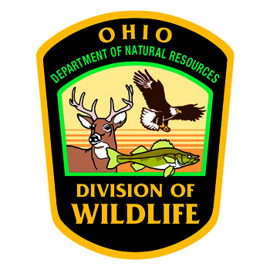
Introductions
Activities:

9:30 Find your mate.
Are You Me?**-p.2-Grades K-4
Other Options:
Animal Charades***-p.280 Grades K-4
Grow As We Go*-p. 38-Ages 3-7

9:45 Habitat lap sit-WILD***-p.61 Grades 5-8

10:00 Thicket Game***-p.114 Grades pre-K-4
Other options:
Hiding in Plain Sight*-p.34 Ages 3-7
Fashion a Fish**-p.98 Grades K-6

Overview of Guidebooks

10:30 BREAK

10:45 Oh Deer, Deer Dilemma*** and Moose story***-p.36 Grades 5-8
Other options:
Oh Deer*-p.48 Ages 3-7
Where Have All the Salmon Gone?**-p. 254 Grades 6-12

11:30 How many bears live in the woods?***-p.23 Grades 5-8

12:00 LUNCH - Bring a sack lunch

12:30 Brief Remarks-Becky McCleary-Public Outreach Chair for the
Cuyahoga River Area of Concern (AOC) & City of Cuyahoga
Falls Public Utilities Consumer Advocate.

1:30 Turtle Hurdles/What is in the water?** -pp.246 &206 Grades 4-

6-8
Other options
Terrific Turkeys*-p.44 Ages 3-7 years
Quick Frozen Critters***-p.122 Grades 5-8

2:00 Project WILD Guide Safari

2:20 Bird Beak Buffet*-p.42 Ages 3-7
Tracks***-p.30 Grades 5-8
Tracks*-p.36 Ages 3-7

2:30 Hazardous Links***-p.326 Grades 7-8

3:00-4:00 Peer teaching from Project Wild and Project Aquatic
4:00-4:30 Closing words, parting gifts, prizes & evaluations

The Ohio Department of Natural Resources (ODNR) Division of Wildlife provides the Project Wild, Growing Up Wild, and Aquatics materials.


Project Wet Curriculum and Activity Guide 2.0
Agenda: Tuesday, August 7, 2018, Shady Bend shelter at Waterworks Park

Activities:
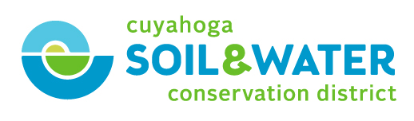
8:30 Raining Cats and Dogs****-p. 521 Grades 3-8

8:40 The Incredible Journey****-p. 155 Grades 3-12

8:50 Poison Pump****-p.107 Grades 6-8

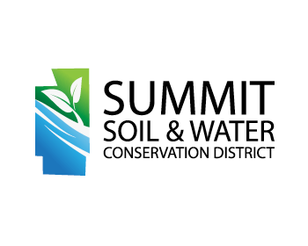
9:20 A Grave Mistake****-p. 315 Grades 6-12

9:50 BREAK

10:00 A Drop in the bucket****-p. 257 Grades 6-8

10:30 Hanging Together****-p.19 Grades 6-8

11:00 Macro invertebrate Mayhem****-p.343 Grades 3-8

11:30 The Thunderstorm****-p.209 Grades Pre-K-8

12:00 LUNCH-Bring a sack lunch
Tour Kelsey Creek: stream restoration if time permits and Brief Remarks-Becky McCleary-Public Outreach Chair for the
Cuyahoga River Area of Concern (AOC) & City of Cuyahoga
Falls Public Utilities Consumer Advocate.
Groundwater model Set Up Available-Grades K-12

1:15 Special Presentation-Water Water Everywhere-Dave Young-Cuyahoga Falls Water Treatment Plant Supervisor.
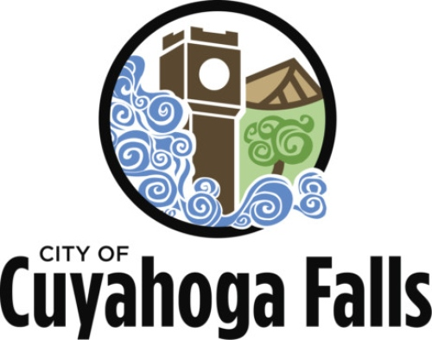
2:10 Adventures in Density****-p.3 Grades 6-8

2:40 Molecules in Motion****-p.33 Grades Pre-K-5

3:00 Color Me a Watershed****-p. 239 Grades 6-12

3:30 Peer Teaching 4 from Project Wet

4:00 Closing words, parting gifts, prizes & evaluations
This day requires an $27.00 fee

Workbooks:

*Growing Up WILD-ages 3-7 years
**Aquatic WILD-K-12th grade
***Project WILD-K-12th grade
****Project Wet-Pre-K-12th grade
*****Wonders of Wetlands-K-12th grade

Wonders of Wetlands Agenda-Wednesday,
August 8th, 2017-University of Akron Field
Station

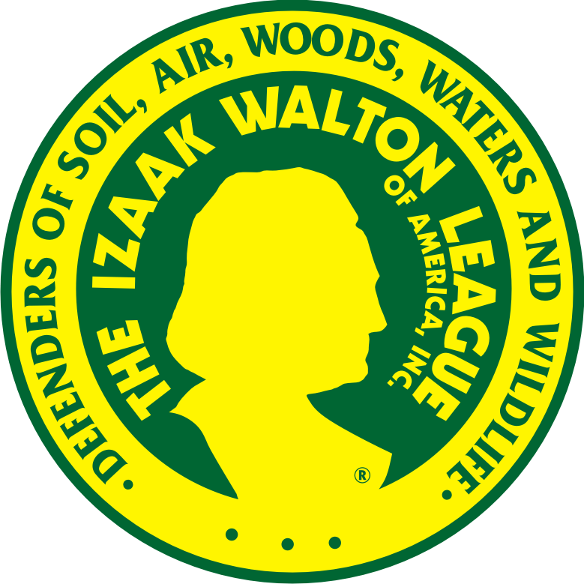
8:30-Registration, Coffee, Welcome and Introduction to Wonders of Wetlands.

Activities:

9:00-Private Eye and Wetland Weirdos-*****p. 94 Grades 4-12

9:40-Wetland in a Pan*****p. 212 Grades 3-12

10:20-Break

10:30-Do You Dig Soil?*****p. 231 Grades K-12

11:00-Wetland Metaphors*****p. 85 Grades 1-12

11:40-Near Zero Waste Free Lunch and Walking Tour

12:45-Enviroscape-Presentation, Ivan Hack, Isaac Walton League
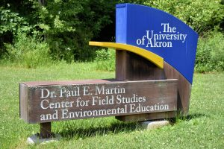
1:30-What a Boat*****p.279 Grades 1-5

2:30-Wetland Wheel*****p. 129 Grades 4-12

3:00-Peer Teaching-Pick a Topic

4:00-Closing Words and evaluations.

WOW, Wet and Wild In The Parks
3-Day Workshop
Please Print Legibly

Name___________________________________________________________

Home Address____________________________________________________

School_______________________________grade_______________________

Subject(s)________________________________________________________

Or
Informal Education Setting_____________________________________________

Email address_______________________________________________________

Sign up for: August 6 August 7 August 8

Please Print Legibly

Deadline July 15, 2018
For more information contact Gene Easter GLEaster@sbcglobal.net
330-928-6691

To reserve your spot, e-mail your registration form to: GLEaster@sbcglobal.net
Include $45.00 fee make personal or bank check out and send to Gene Easter.
To: Gene Easter
540 S. Ridgecliff St.
Tallmadge OH 44278

